**Problem-02:**

Consider the following heap (figure) in which blank regions are not in use and hatched regions are in use-

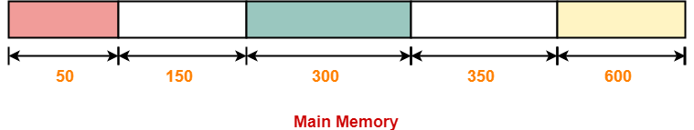

The sequence of requests for blocks of size 300, 25, 125, 50 can be satisfied if we use-

1. Either first fit or best fit policy (any one)
2. First fit but not best fit policy
3. Best fit but not first fit policy
4. None of the above

**Solution-**

The allocation follows variable size partitioning scheme.

Let us say the given processes are-

* Process P1 = 300 units
* Process P2 = 25 units
* Process P3 = 125 units
* Process P4 = 50 units

**Allocation Using First Fit Algorithm-**

The allocation of partitions to the given processes is shown below-

**Step-01:**

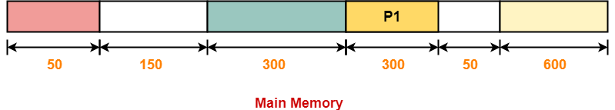

**Step-02:**

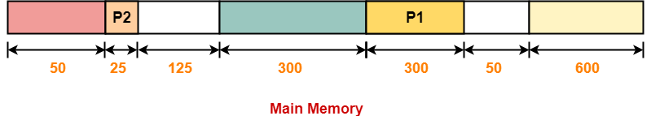

**Step-03:**

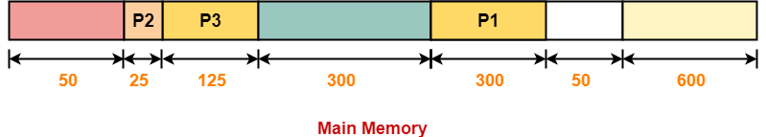

**Step-04:**

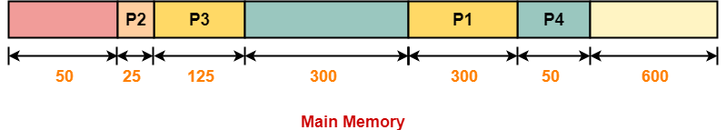

**Allocation Using Best Fit Algorithm-**

**The allocation of partitions to the given processes is shown below-**

**Step-01:**



**Step-02:**

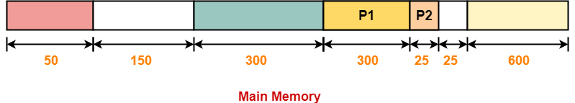

**Step-03:**

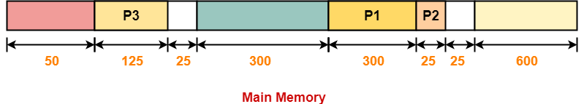

**Step-04:**

* **Process P4 can not be allocated the memory.**
* **This is because no partition of size greater than or equal to the size of process P4 is available.**

**Thus,**

* **Only first fit allocation policy succeeds in allocating memory to all the processes.**
* **Option (B) is correct.**